**How to Log into Microsoft Teams**

1. Launch the Teams app



1. Select Sign-in
   1. Sign-in address: district [username@slps.org](mailto:username@pcsb.org) ([jdoe1234@slps.org](mailto:r2.d2@pcsb.org))
   2. Complete sign-in process by entering student password

Navigating Microsoft Teams

* Once signed in, the application will start on the Activity page. The activity page lists all activity within the Teams platforms. Select the Teams icon on the lower navigation bar to view your class(es).
* Use the dropdown next to the class name to access the general channel. Here you can access the class discussions, files, assignments, and digital notebook by selecting the appropriate tab across the top.

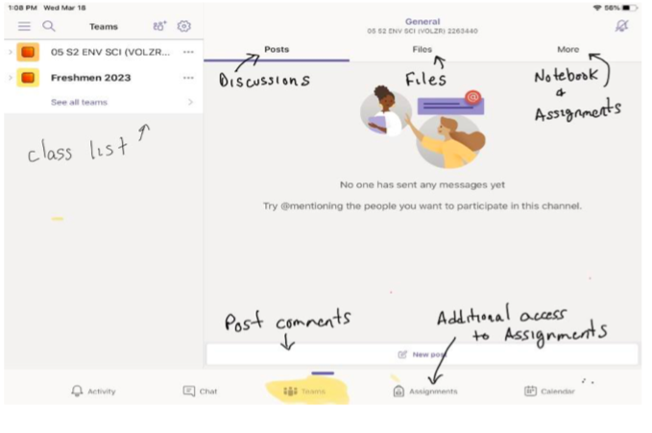

Multiple Users/Switching Accounts

Only one student at a time can be signed-in to Teams. If multiple students are using the same iPad, each student must sign out prior to the next student signing in. Follow the steps below to sign out.

1. Select the options menu
2. Choose Sign Out from the list

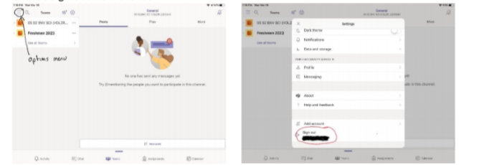

1. App is now ready for next student to log in

For additional assistance please visit <https://support.microsoft.com/en-us/office/distance-learning-with-office-365-guidance-for-parents-and-guardians-89d514f9-bf5e-4374-a731-a75d38ddd588?ui=en-us&rs=en-us&ad=us>